Automated Agreements Invoices & Client Document Workflow
Make.com | Google Sheets | Google Docs | Google Drive | SmartSuite

Project Overview
Built an automated document processing system for managing client agreements, invoices, folders, and sales pitch files.
The workflow takes pending client records and automatically creates the required documents, organizes files, updates processing status, and keeps Google Sheets and SmartSuite synchronized.
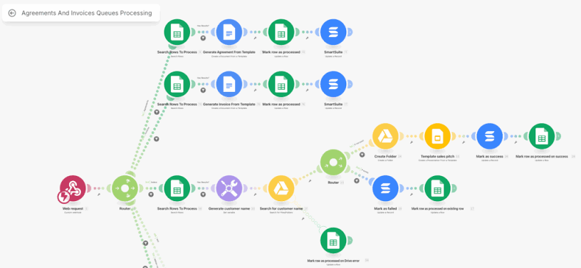
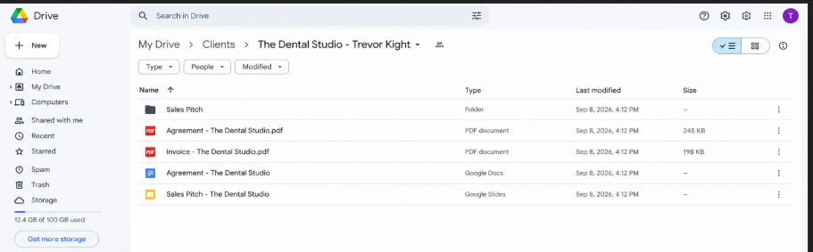

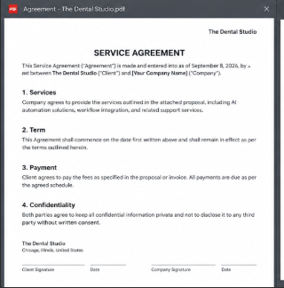
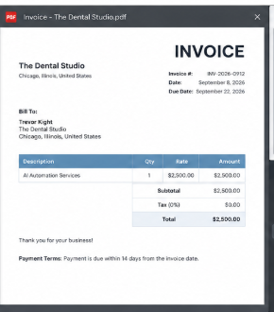
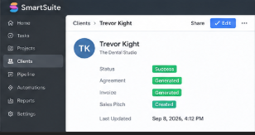

Workflow
The system:
- Receives a processing request through a webhook
- Retrieves pending agreement records from Google Sheets
- Generates agreements automatically from document templates
- Retrieves pending invoice records from Google Sheets
- Generates invoices automatically from predefined templates
- Creates a standardized customer name for file management
- Searches Google Drive for the customer folder
- Creates a new customer folder when required
- Generates the customer sales pitch from a template
- Updates SmartSuite with success or failure status
- Marks processed records in Google Sheets
- Handles existing folders and Google Drive processing errors

Branding & Templates
The workflow uses predefined document and sales pitch templates for automated file creation.
Each template controls:
- Customer information
- Agreement content
- Invoice information
- Sales pitch content
- Document structure
This keeps generated client documents consistent while reducing manual document preparation.

Content Management
Google Sheets acts as the central processing queue and tracking system.
Each completed record is updated with:
- Processing status
- Agreement status
- Invoice status
- Customer folder status

Technology
- Make.com
- Google Sheets
- Google Docs
- Google Drive
- SmartSuite
- Webhooks
- Automation Routers

Result
A complete automated document processing pipeline that turns pending client records into organized agreements, invoices, customer folders, and sales pitch files without requiring manual document creation for every client.
The system also keeps processing status, client records, and generated files organized in one workflow.

